**Module-6: Ansible Assignment - 4**

You have been asked to:

● Use the previous deployment of ansible cluster

● Configure the files folder in the role with index.html which should be replaced

with the original index.html

All of the above should only happen on the slave which has nginx installed using the role

**Create the custom index.html**

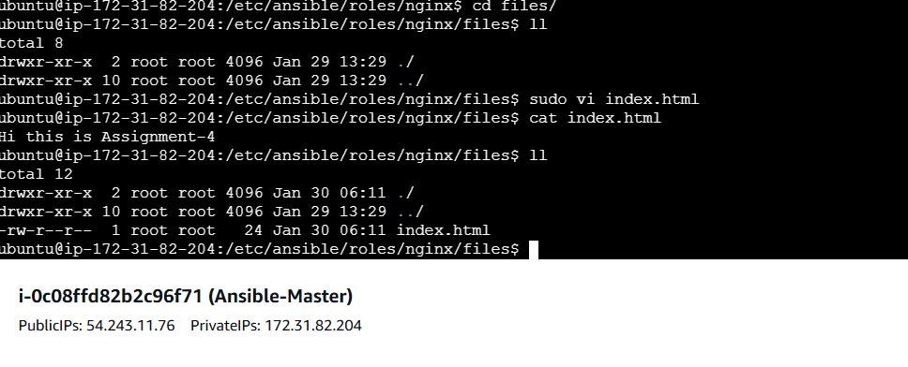

Add tasks in role-]

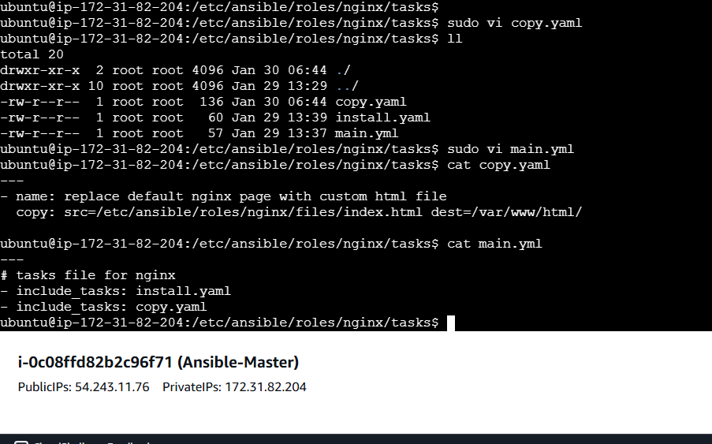

And run the same playbook which was ran in assignment-3

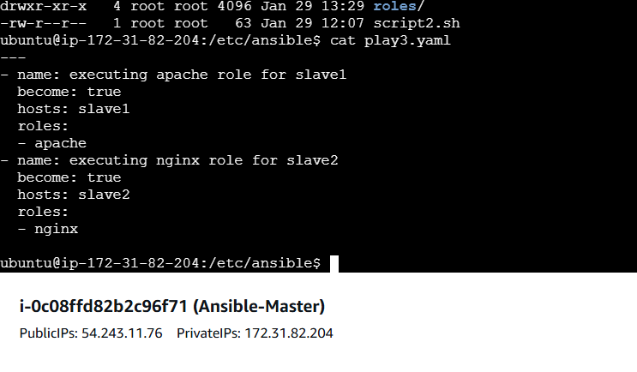

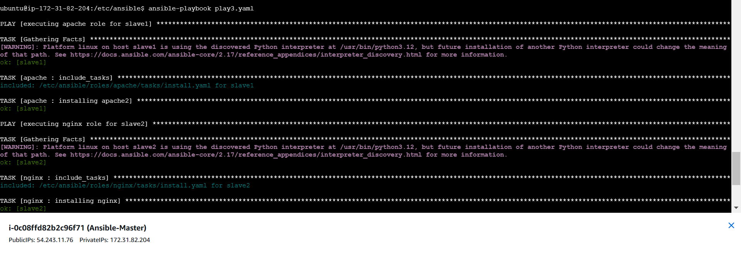

On slave 2 it will update the default page.

Take public Ip of slave-2

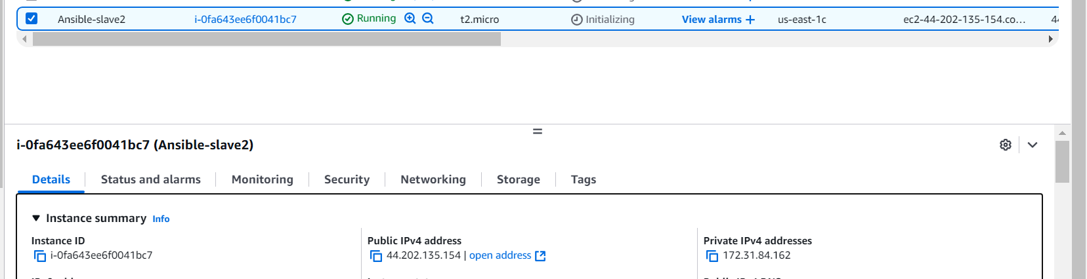

Here is output

